B.M.S. COLLEGE OF ENGINEERING BENGALURU
Autonomous Institute, Affiliated to VTU


Lab Record

Computer Networks – 23CS5PCCON

Submitted in partial fulfillment for the 5th Semester Laboratory

Bachelor of Engineering
in
Computer Science and Engineering

Submitted by:

DISHA D S

(1BM23CS094)

Department of Computer Science and Engineering
B.M.S. College of Engineering
Bull Temple Road, Basavanagudi, Bangalore 560 019
August 2025-December 2025

B.M.S. College of EngineerinG
DEPARTMENT OF COMPUTER SCIENCE AND ENGINEERING



CERTIFICATE

This is to certify that the Computer Networks (23CS5PCCON) laboratory has been carried out by DISHA D S (1BM23CS094) during the 5th Semester August 2025-December 2025

Signature of the Faculty Incharge:

Prof. Sarala D V
Assistant Professor

Department of Computer Science and Engineering
B.M.S. College of Engineering, Bangalore

Table of Contents

PART - A
Serial No. | Name of Expirement
1. | Create a topology and simulate sending a simple PDU from source to destination using hub and switch as connecting devices and demonstrate ping message.
2. | Configure DHCP within a LAN and outside LAN.
3. | Configure Web Server, DNS within a LAN.
4. | Configure IP address to routers in packet tracer. Explore the following messages: ping responses, destination unreachable, request timed out, reply.
5. | Configure default route, static route to the Router.
6. | Configure RIP routing Protocol in Routers.
7. | Configure OSPF routing protocol.
8. | To construct a VLAN and make the PC’s communicate among a VLAN.
9. | To construct a WLAN and make the nodes communicate wirelessly.
10. | Demonstrate the TTL/ Life of a Packet.
11. | To understand the operation of TELNET by accessing the router in server room from a PC in IT office.
12. | To construct simple LAN and understand the concept and operation of Address Resolution Protocol (ARP).

PART – B
Serial No. | Name of Expirement
1. | Write a program for congestion control using Leaky bucket algorithm.
2. | Using TCP/IP sockets, write a client-server program to make client sending the file name and the server to send back the contents of the requested file if present.
3. | Using UDP sockets, write a client-server program to make client sending the file name and the server to send back the contents of the requested file if present.
4. | Write a program for error detecting code using CRC-CCITT (16-bits).

PART - A
Program 1: Create a topology and simulate sending a simple PDU from source to destination using hub and switch as connecting devices and demonstrate ping message.
Network diagram:
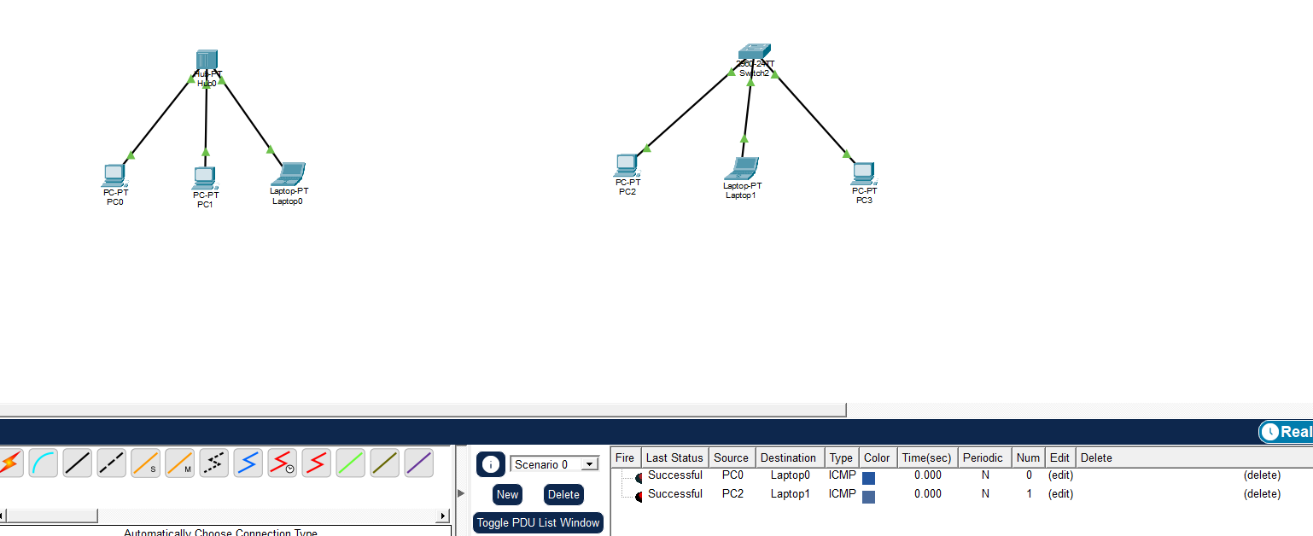
Configuration:
DEVICE | IP ADDRESS | SUBNET MASK
PC0 | 192.168.1.1 | 255.255.255.0
PC1 | 192.168.1.2 | 255.255.255.0
LAPTOP0 | 192.168.1.3 | 255.255.255.0
PC2 | 192.168.1.4 | 255.255.255.0
LAPTOP1 | 192.168.1.5 | 255.255.255.0
PC3 | 192.168.1.6 | 255.255.255.0

Ping message:
HUB:
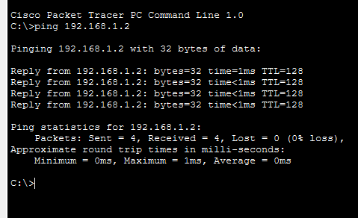

SWITCH
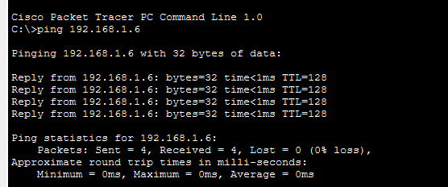

Program 2: Configure DHCP within a LAN and outside LAN.
Network diagram:
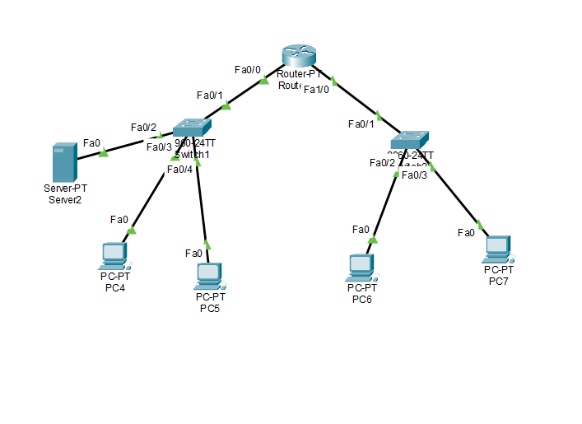
Configuration:
Server2 IP- 192.168.10.2
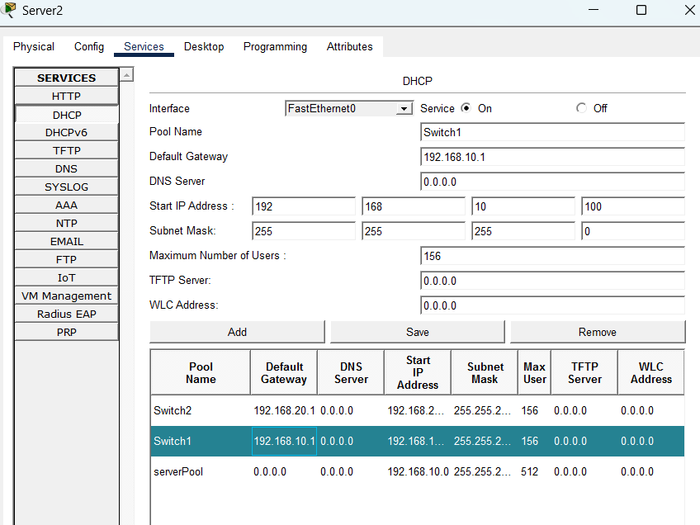
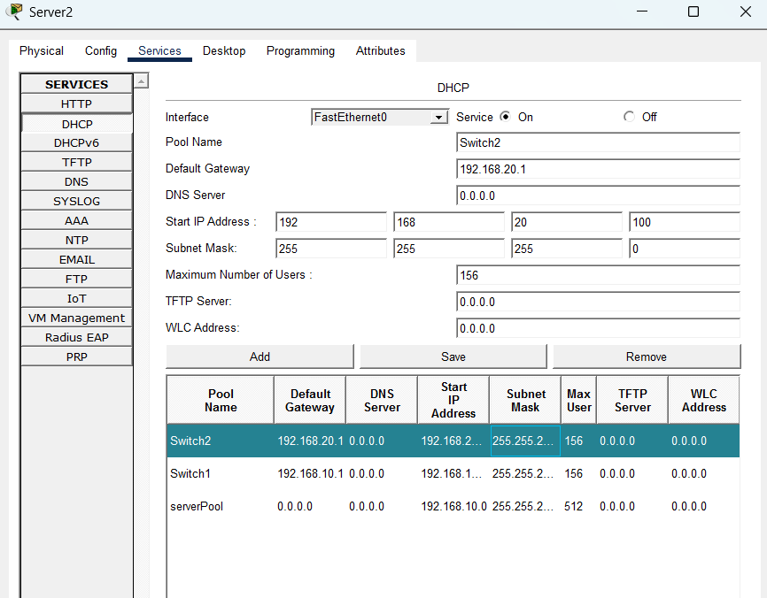

Router configuration
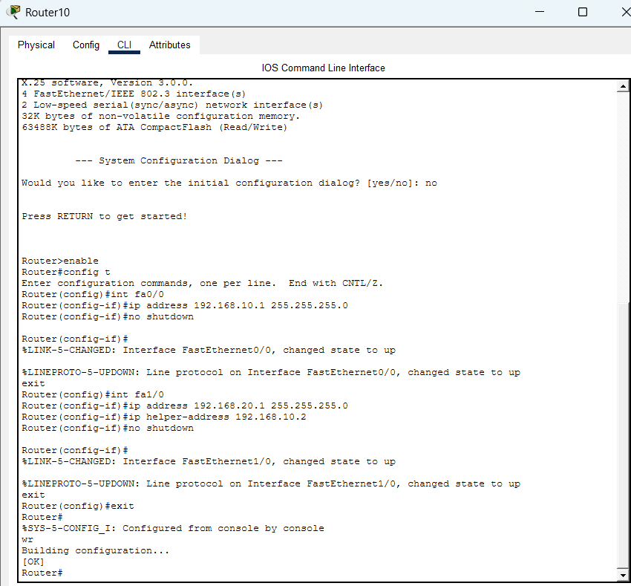

All PCs IP is set to DHCP

Ex PC4
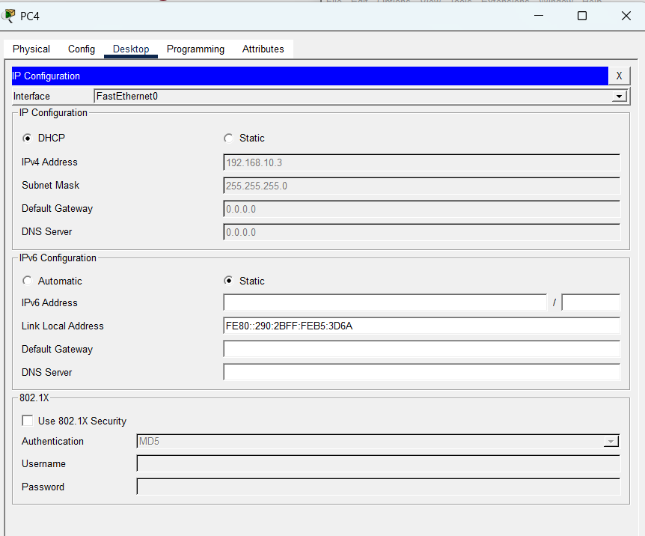

Program 3: Configure Web Server, DNS within a LAN.
Network diagram:
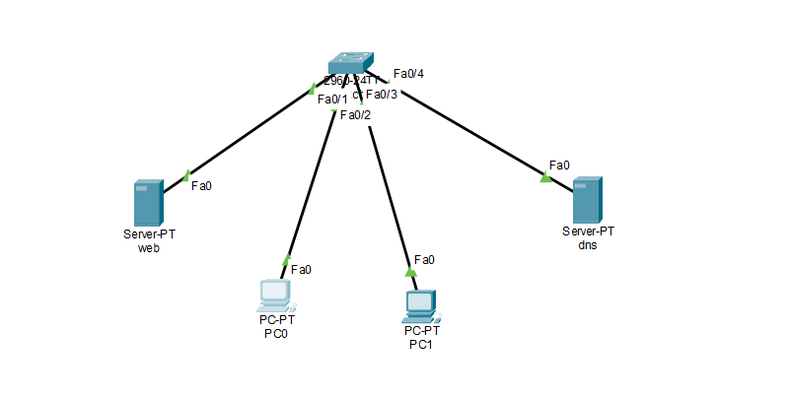

Configuration:
Device | Ip address | Dns address
PC0 | 192.168.10.1 | 192.168.10.5
PC1 | 192.168.10.2 | 192.168.10.5
Web server | 192.168.10.6 | 192.168.10.5
DNS server | 192.168.10.5 | 192.168.10.5
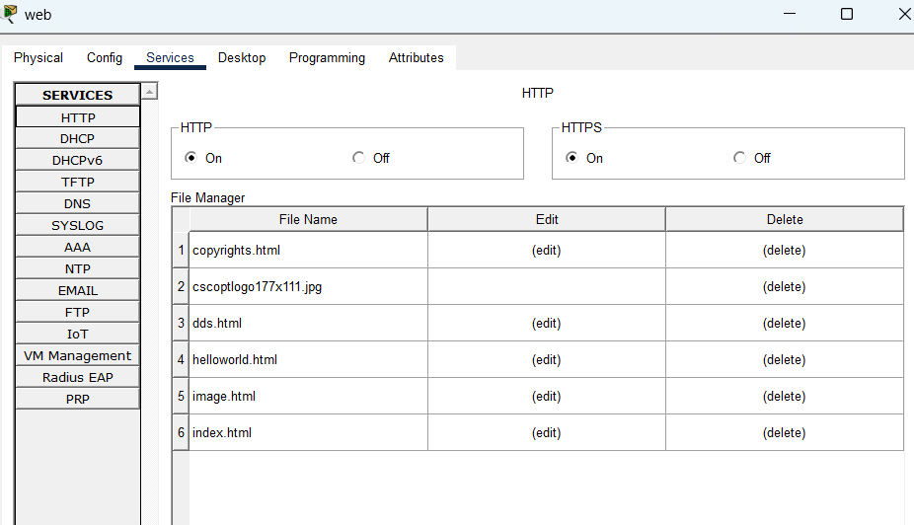
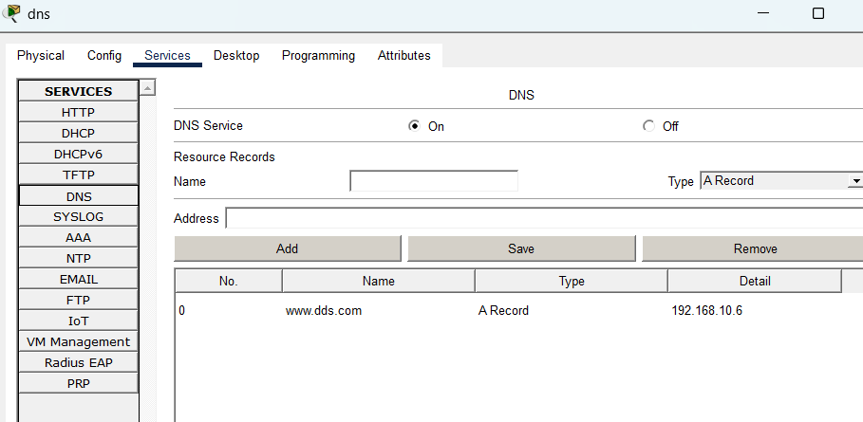
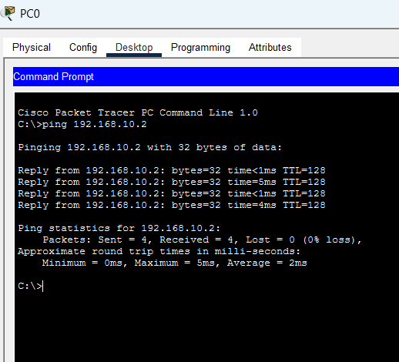
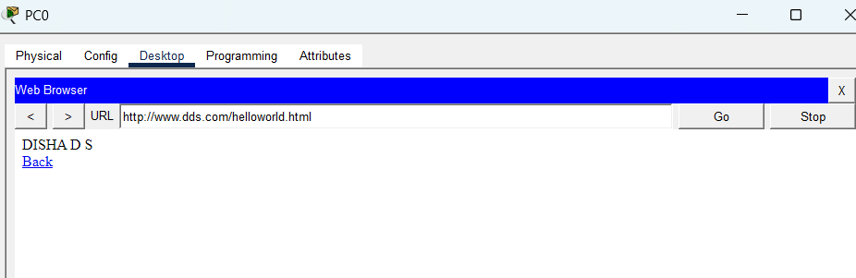

Program 4: Configure IP address to routers in packet tracer. Explore the following messages: ping responses, destination unreachable, request timed out, reply.
Network diagram:
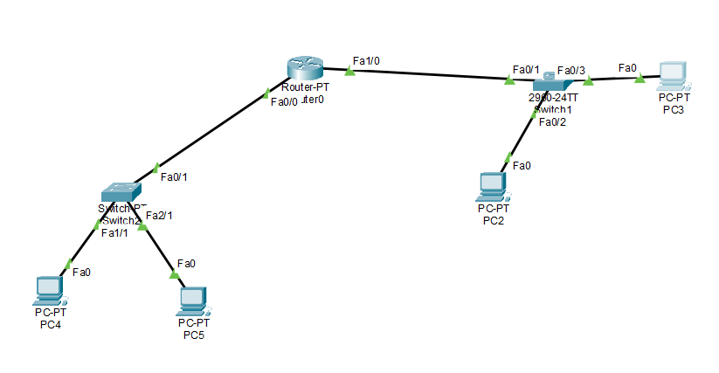
Configuration:
Device | Ip address
PC4 | 192.168.20.2
PC5 | 192.168.20.3
PC2 | 192.168.30.10
PC3 | 192.168.30.11

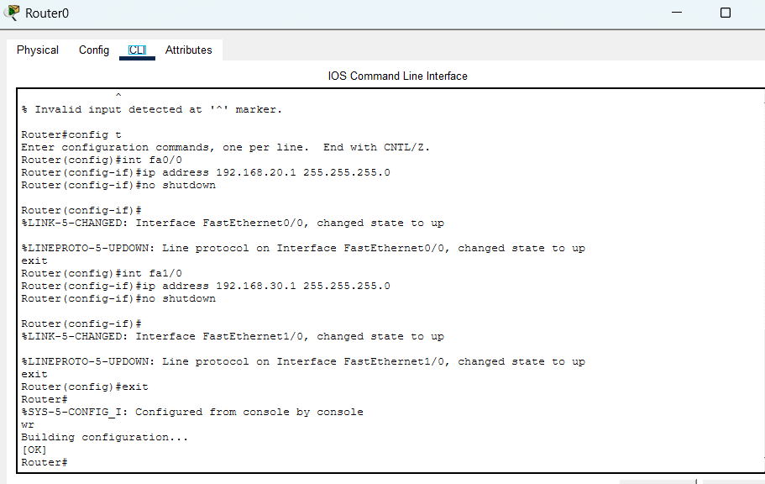
Request timed out when default gateway not set
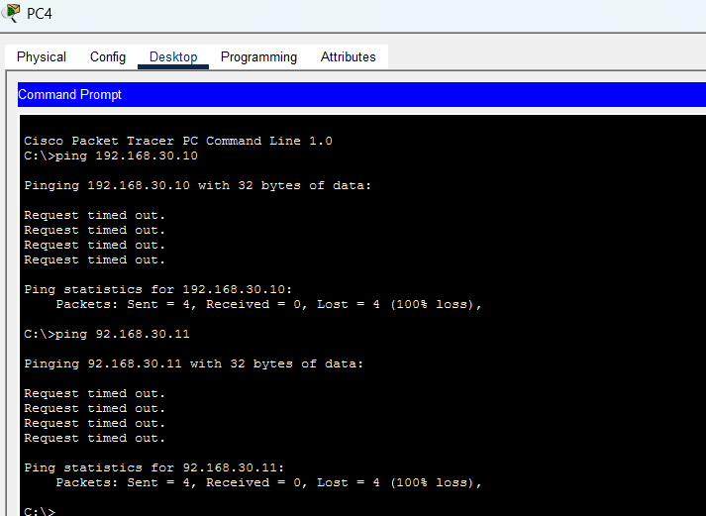

Ping successful
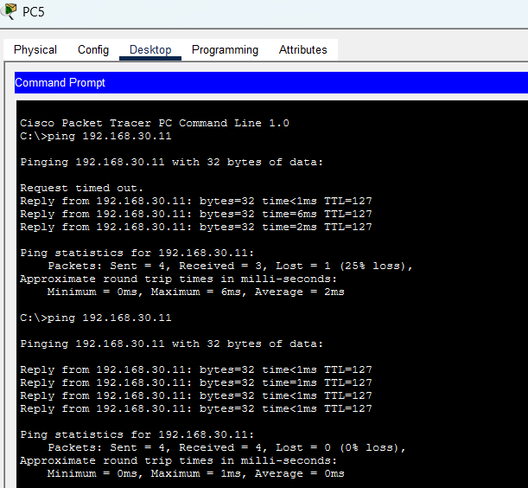

Destination unreachable when an ip address not in network given
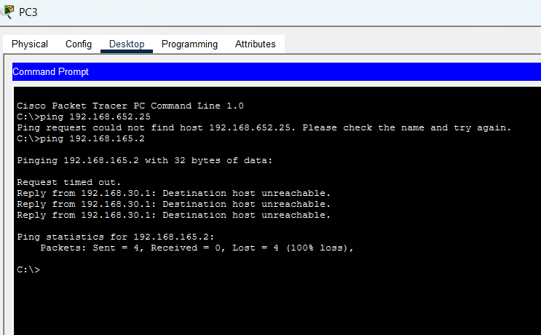

Program 5: Configure default route, static route to the Router.
Network diagram:
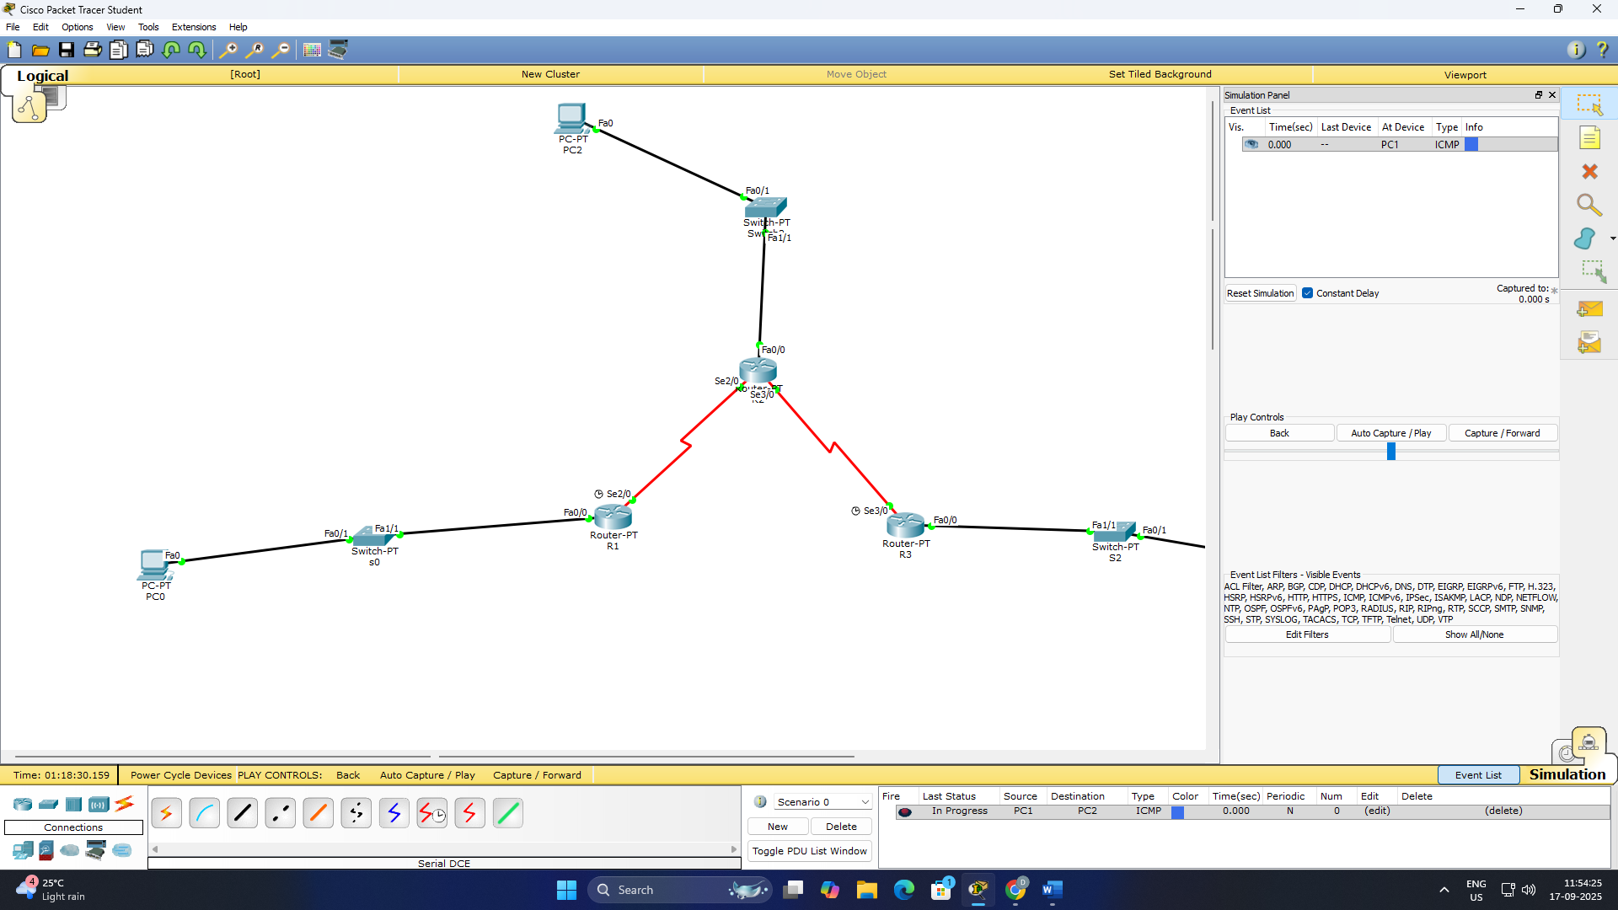
Configuration:
DEVICE | IP | DEFAULT GATEWAY
PC0 | 192.168.10.10 | 192.168.10.1
PC1 | 192.168.20.10 | 192.168.20.1
PC2 | 192.168.30.10 | 192.168.30.1

R1: FA0/0-192.168.10.1 , 255.255.255.0
SE2/0- 172.16.1.1 , 255.255.255.252
R2: FA0/0- 192.168.20.1, 255.255.255.0
SE2/0- 172.16.1.2, 255.255.255.252
SE3/0- 172.16.2.1, 255.255.255.252
R3: SE3/0- 17.16.2.2, 255.255.255.252
FA0/0- 192.168.30.1, 255.255.255.0

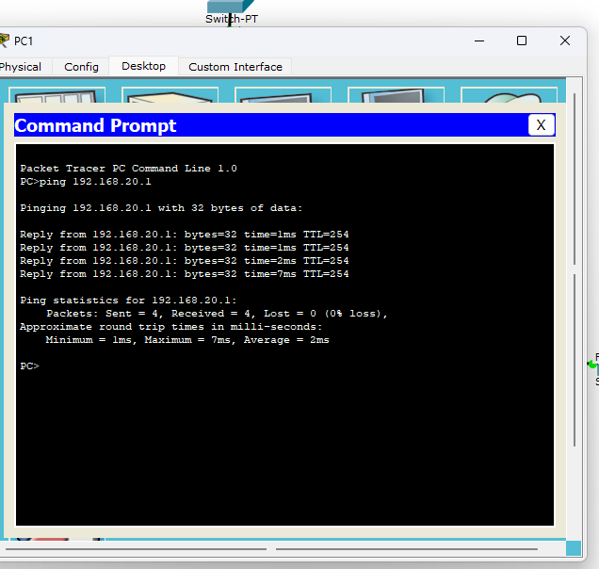

Program 6: Configure RIP routing Protocol in Routers.
Network diagram:
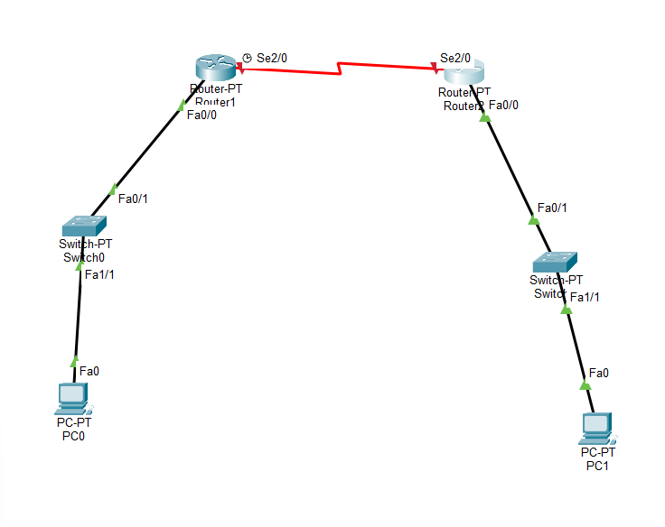
Configuration:
Device | Interface | IP Address | Subnet Mask | Default Gateway
PC0 | NIC | 192.168.20.2 | 255.255.255.0 | 192.168.1.1
R1 | FastEthernet0/0 | 192.168.20.1 | 255.255.255.0 | —
R1 | Serial2/0 | 10.10.0.2 | 255.255.255.252 | —
R2 | Serial2/0 | 10.10.0.3 | 255.255.255.252 | —
R2 | FastEthernet0/0 | 192.168.10.1 | 255.255.255.0 | —
PC1 | NIC | 192.168.10.2 | 255.255.255.0 | 192.168.2.1

Program 7: Configure OSPF routing protocol.
Network diagram:
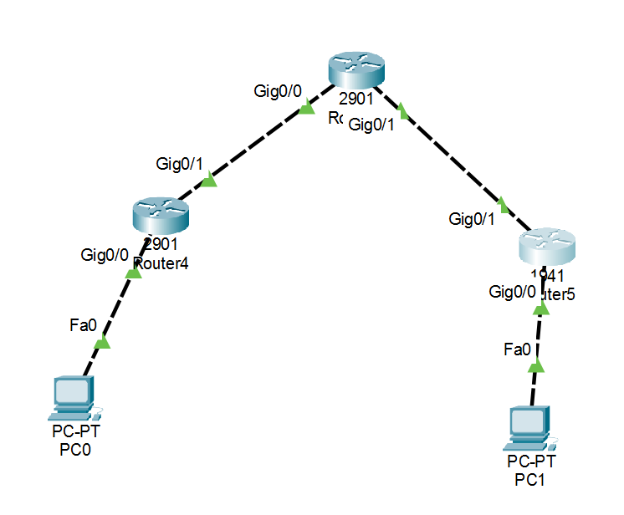
Configuration:
Device | IP Address | Subnet Mask | Default Gateway
PC0 | 192.168.55.2 | 255.255.255.0 | 192.168.55.1
PC1 | 192.168.44.2 | 255.255.255.0 | 192.168.44.1
PC2 | 10.10.22.2 | 255.255.255.0 | 10.10.22.1

R3:
Interface | IP Address | Subnet Mask
GigabitEthernet0/0 | 192.168.55.1 | 255.255.255.0
GigabitEthernet0/1 | 176.16.10.1 | 255.255.255.0

R4:
Interface | IP Address | Subnet Mask
GigabitEthernet0/0 | 192.168.44.1 | 255.255.255.0
GigabitEthernet0/1 | 192.168.55.0 | 255.255.255.0

R5:
Interface | IP Address | Subnet Mask
GigabitEthernet0/0 | 176.16.10.2 | 255.255.255.0
GigabitEthernet0/1 | 10.10.22.1 | 255.255.255.0

Program 8: To construct a VLAN and make the PC’s communicate among a VLAN.
Network diagram:
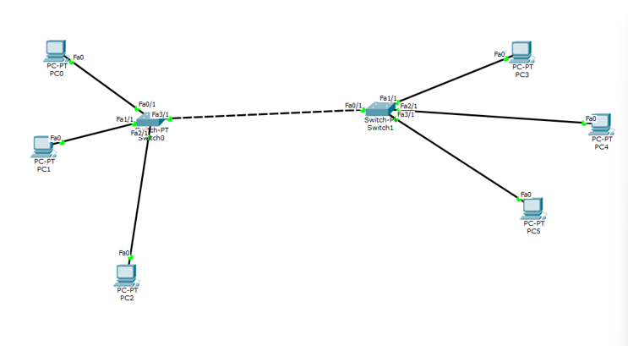
Configuration:
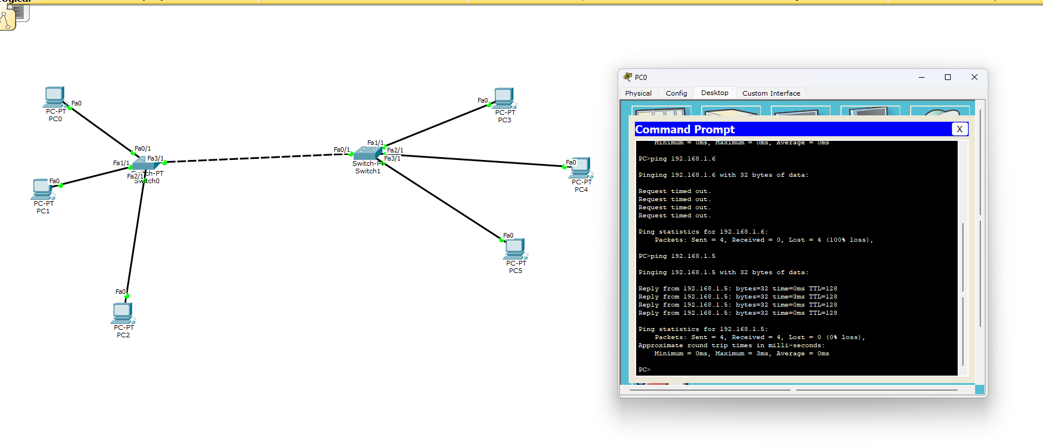
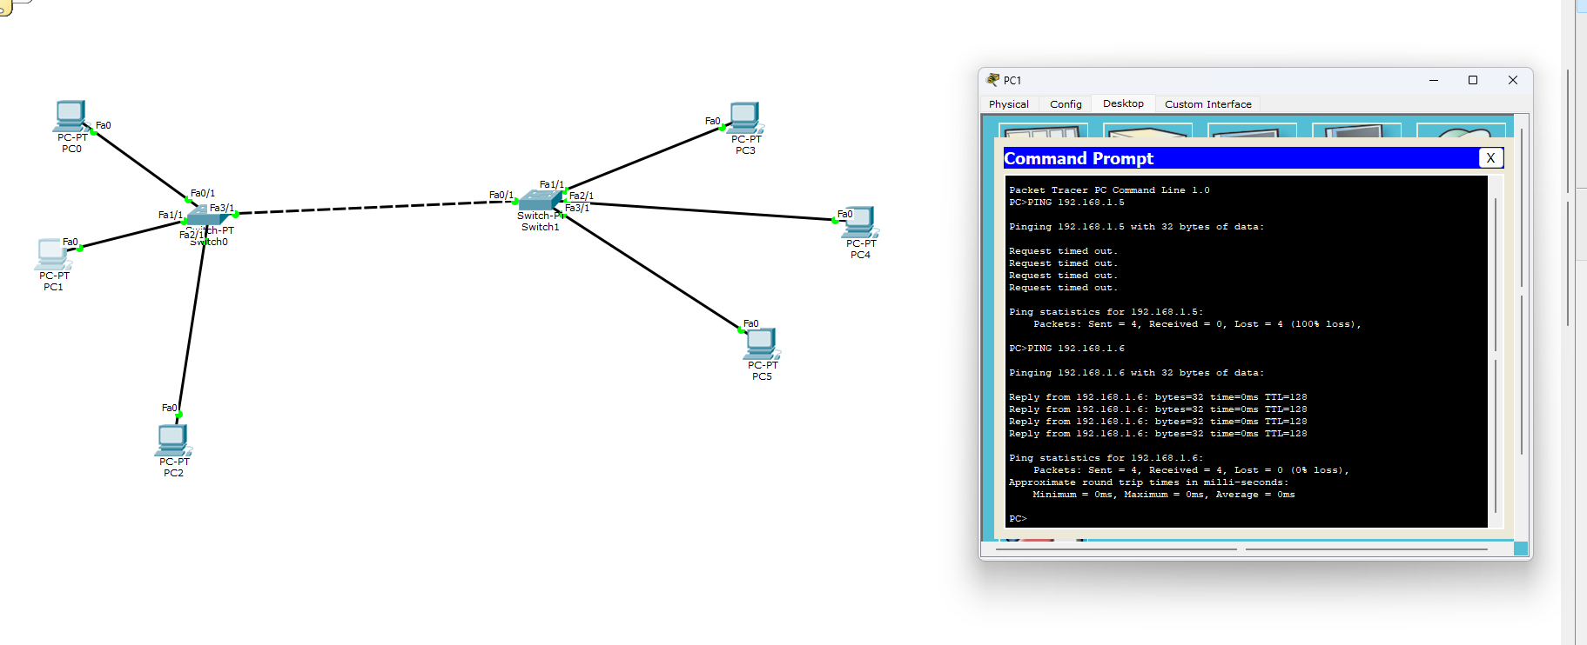

Program 9: To construct a WLAN and make the nodes communicate wirelessly.
Network diagram:
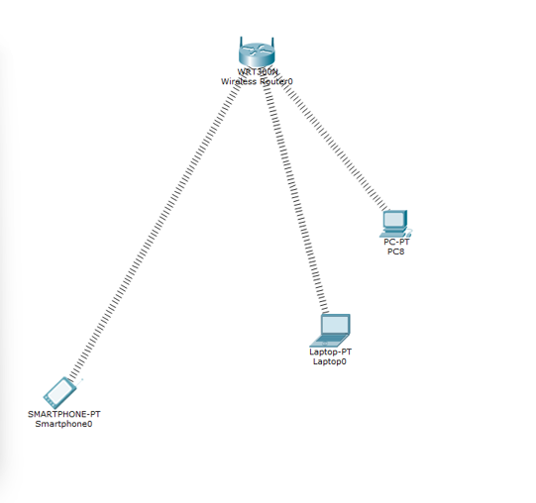
Configuration:
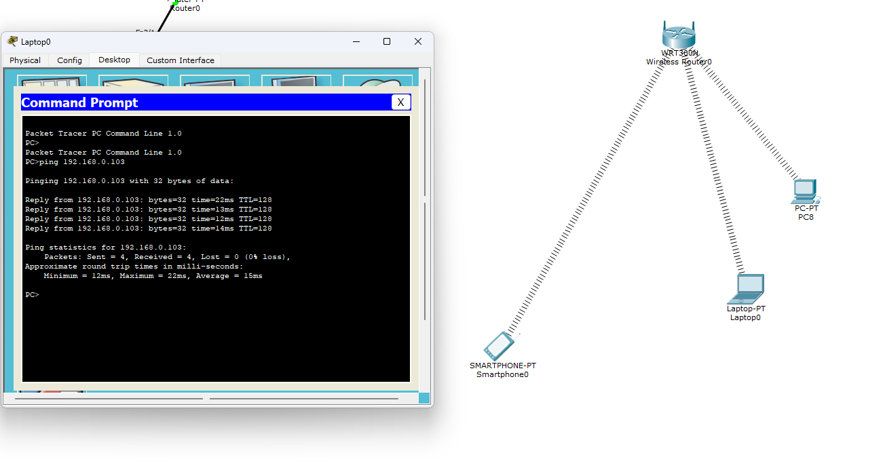

Program 10: Demonstrate the TTL/ Life of a Packet.
Network diagram:
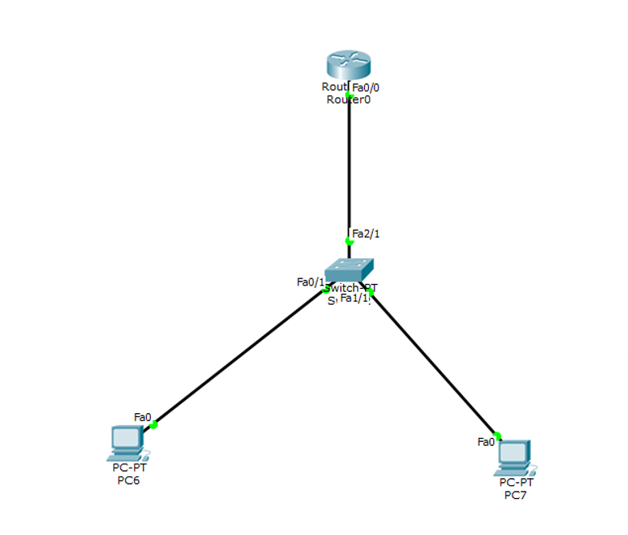
Configuration:
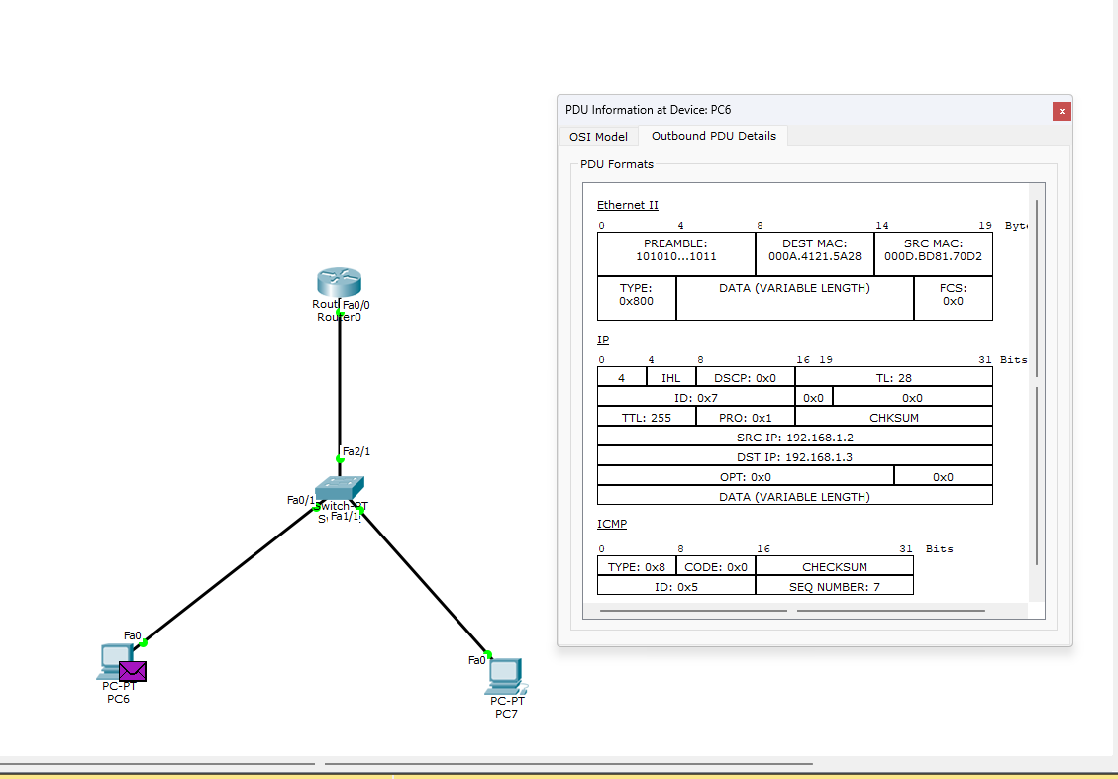

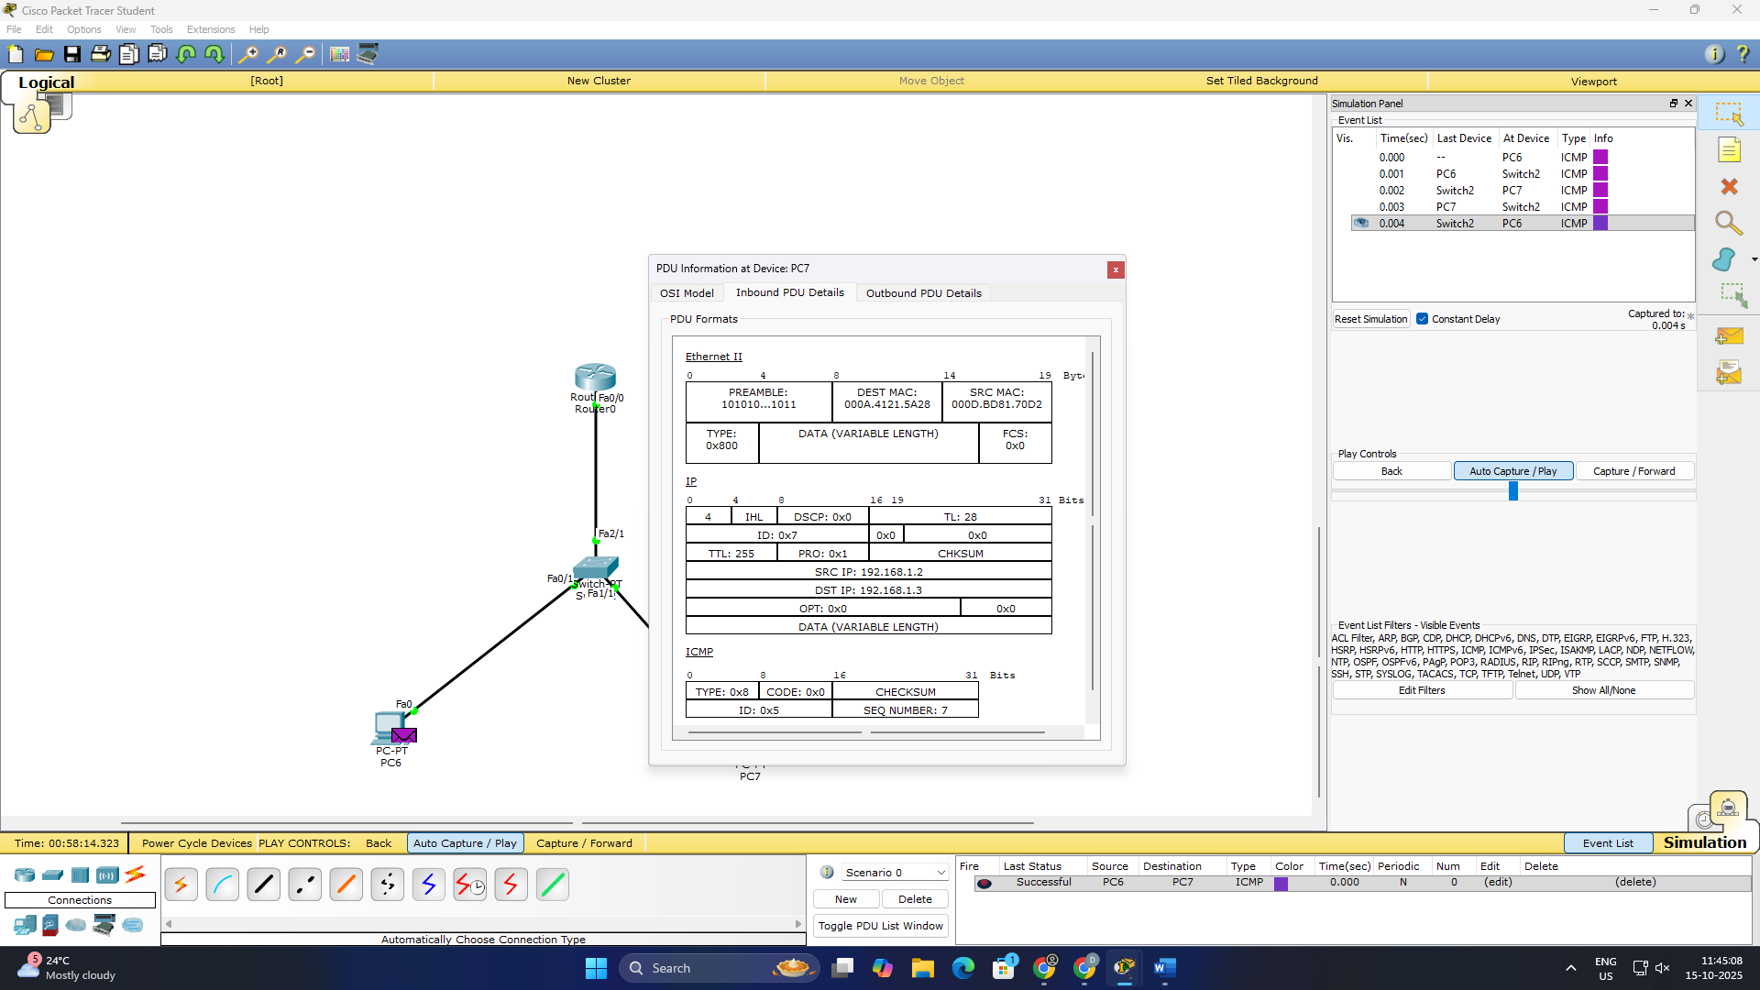

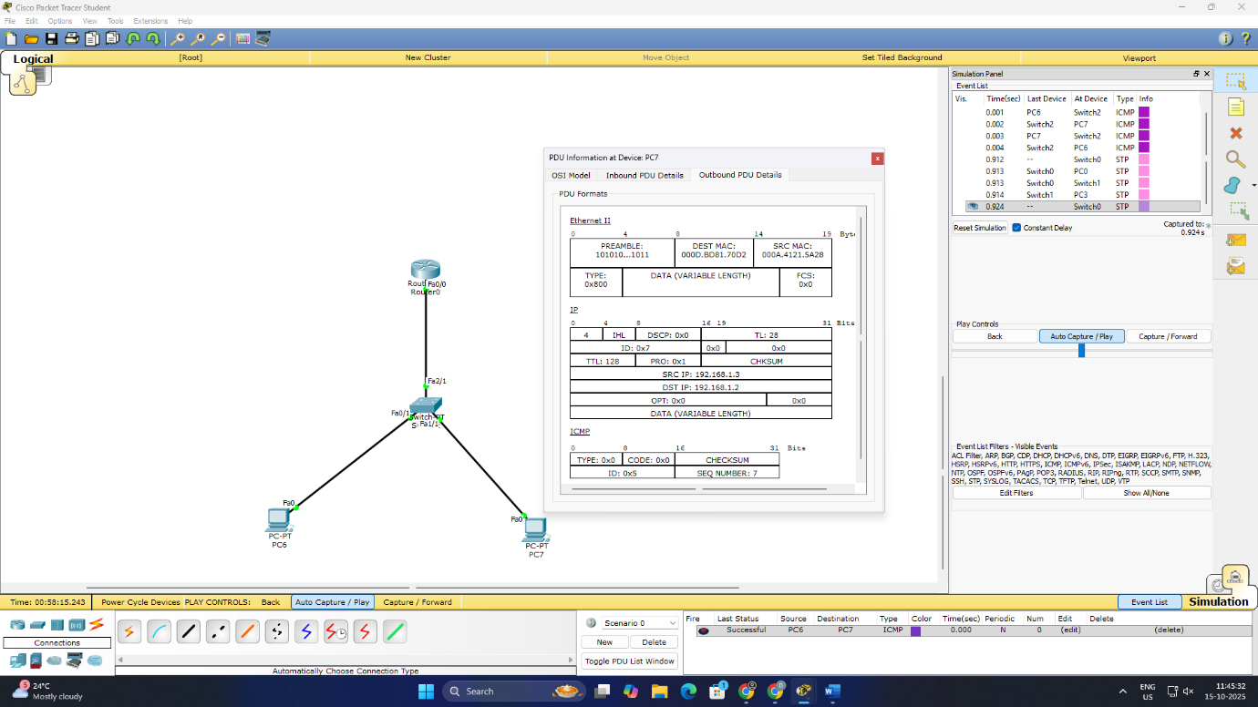

Program 11: To understand the operation of TELNET by accessing the router in server room from a PC in IT office.
Network diagram:
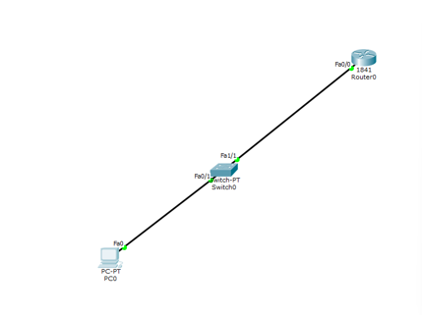
Configuration:

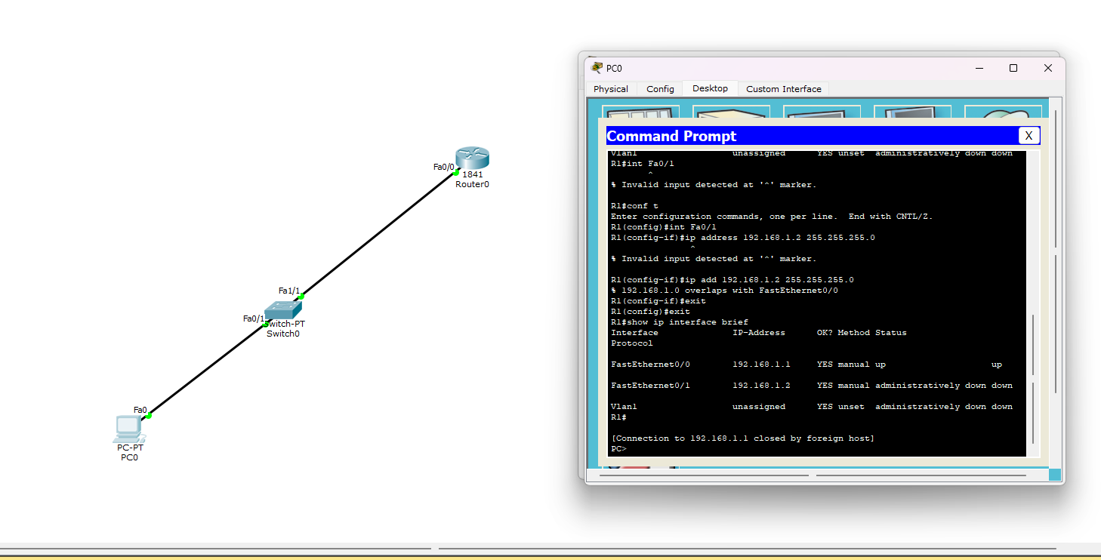

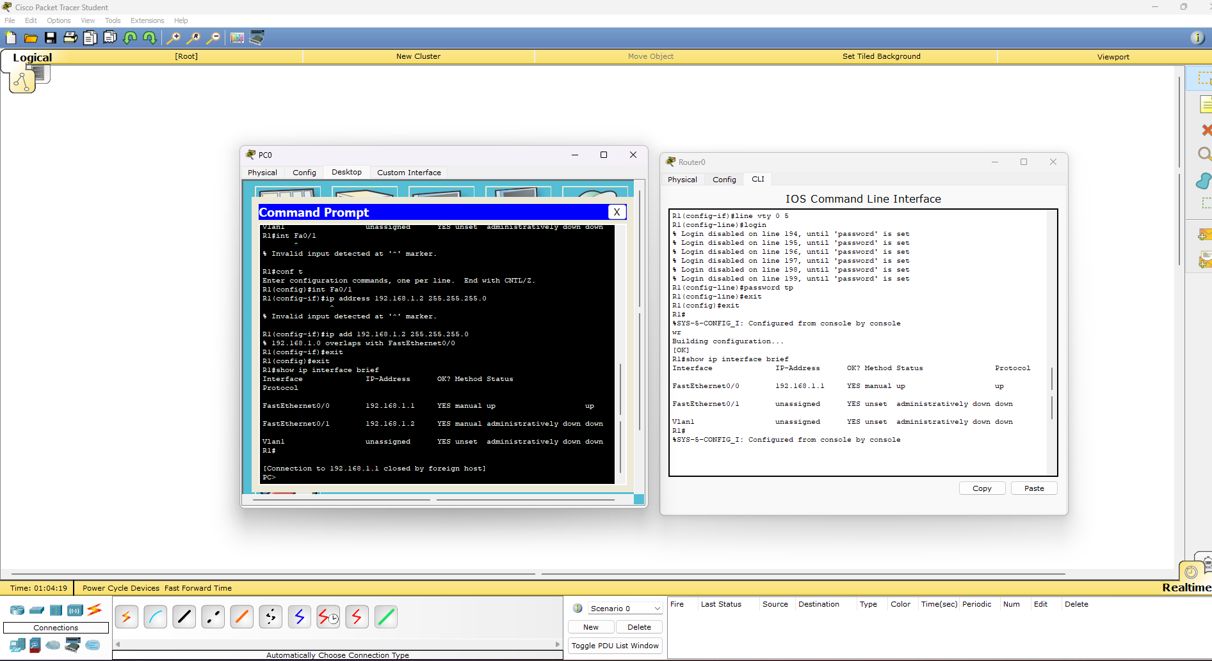

Program 12: To construct simple LAN and understand the concept and operation of Address Resolution Protocol (ARP).
Network diagram:
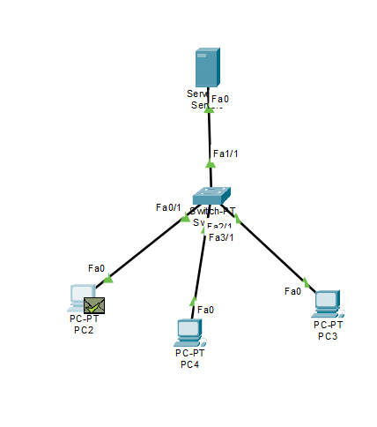
Configuration:
Server0-192.168.11.4
Pc2-192.168.11.1
Pc4-192.168.11.3
Pc3-192.168.11.2
DNS – 192.168.11.4
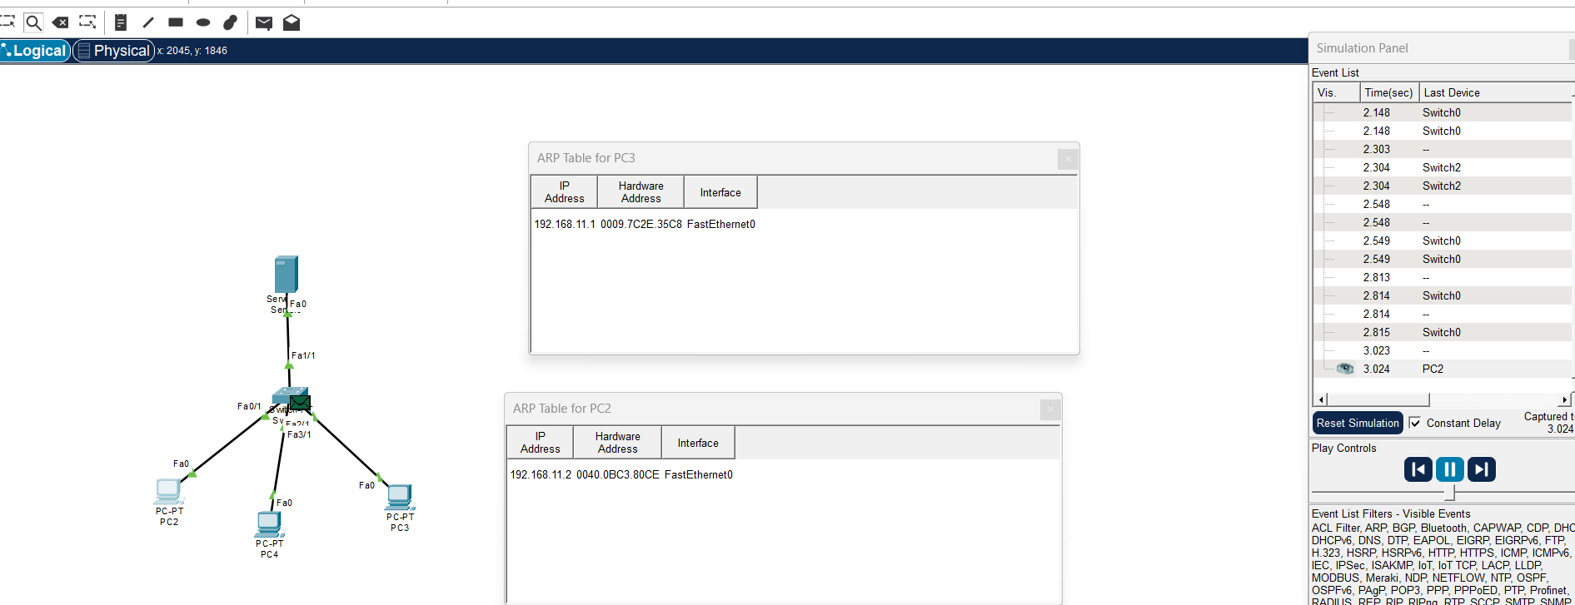

PART - B
Program 1: Write a program for congestion control using Leaky bucket algorithm.
Code:
#include <stdio.h>

int min(int x, int y) {
return (x < y) ? x : y;
}

int main() {
int cap, process, nsec;
int inp[25];
int count = 0, drop = 0, mini;

printf("Enter the bucket size:\n");
scanf("%d", &cap);

printf("Enter the processing rate:\n");
scanf("%d", &process);

printf("Enter the number of seconds you want to simulate:\n");
scanf("%d", &nsec);

for(int i = 0; i < nsec; i++) {
printf("Enter the size of the packet entering at %d sec:\n", i+1);
scanf("%d", &inp[i]);
}

printf("\nSecond | Packet Recvd | Packet Sent | Packet Left | Dropped\n");
printf("---------------------------------------------------------------\n");

// Main simulation for given seconds
for(int i = 0; i < nsec; i++) {
count += inp[i]; // packets received

if(count > cap) {
drop = count - cap;
count = cap;
}

mini = min(count, process); // process packets
count -= mini;

printf("%6d | %12d | %11d | %11d | %7d\n", i+1, inp[i], mini, count, drop);
drop = 0;
}

// Flush the remaining packets after time ends
int i = nsec;
while(count > 0) {
if(count > cap) {
drop = count - cap;
count = cap;
}

mini = min(count, process);
count -= mini;

printf("%6d | %12d | %11d | %11d | %7d\n", i+1, 0, mini, count, drop);
drop = 0;
i++;
}

return 0;
}

Output:
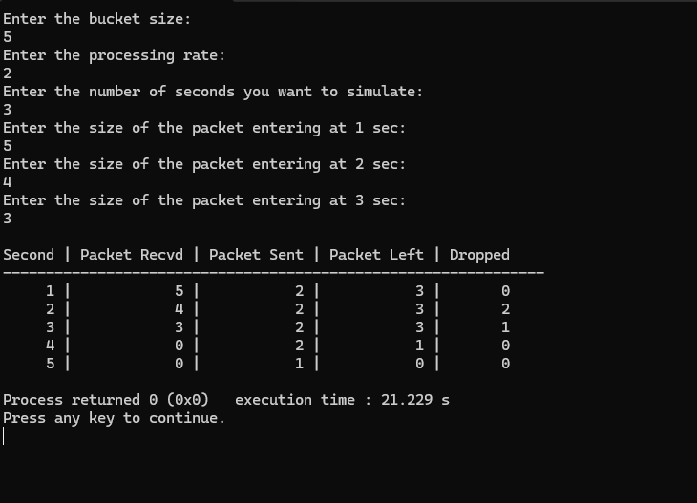

Program 2: Using TCP/IP sockets, write a client-server program to make client sending the file name and the server to send back the contents of the requested file if present.
Code:
SERVER CODE (Server.c)
#include <stdio.h>
#include <stdlib.h>
#include <string.h>
#include <unistd.h>
#include <netinet/in.h>

int main(int argc, char *argv[])
{
int sockfd, newsockfd, portno;
char buffer[256], data[20000];
struct sockaddr_in serv, cli;
socklen_t len;
FILE *fp;

if (argc < 2)
{
printf("Error: No port number provided\n");
printf("Usage: ./server <portno>\n");
exit(1);
}

sockfd = socket(AF_INET, SOCK_STREAM, 0);

serv.sin_family = AF_INET;
serv.sin_addr.s_addr = INADDR_ANY;
serv.sin_port = htons(atoi(argv[1]));

bind(sockfd, (struct sockaddr *)&serv, sizeof(serv));
listen(sockfd, 5);

len = sizeof(cli);
printf("Server waiting for connection...\n");

newsockfd = accept(sockfd, (struct sockaddr *)&cli, &len);

bzero(buffer, 256);
read(newsockfd, buffer, 255);

printf("Server received filename: %s\n", buffer);

fp = fopen(buffer, "r");

if (fp == NULL)
{
write(newsockfd, "File not found", 14);
printf("File not found\n");
}
else
{
printf("File found. Sending data...\n");
bzero(data, 20000);
while (fgets(buffer, 256, fp) != NULL)
{
strcat(data, buffer);
}
write(newsockfd, data, strlen(data));
printf("File sent successfully\n");
fclose(fp);
}

close(newsockfd);
close(sockfd);

return 0;
}

CLIENT CODE (Client.c)
#include <stdio.h>
#include <stdlib.h>
#include <string.h>
#include <unistd.h>
#include <netinet/in.h>

int main(int argc, char *argv[])
{
int sockfd;
char filename[256], data[20000];
struct sockaddr_in serv;

if (argc < 2)
{
printf("Error: Port number missing\n");
printf("Usage: ./client <portno>\n");
exit(1);
}

sockfd = socket(AF_INET, SOCK_STREAM, 0);

serv.sin_family = AF_INET;
serv.sin_port = htons(atoi(argv[1]));
serv.sin_addr.s_addr = INADDR_ANY;

connect(sockfd, (struct sockaddr *)&serv, sizeof(serv));

printf("Enter file name: ");
scanf("%s", filename);

write(sockfd, filename, strlen(filename));

bzero(data, 20000);
read(sockfd, data, sizeof(data));

printf("\n--- File Content ---\n");
printf("%s\n", data);
printf("--------------------\n");

close(sockfd);
return 0;
}
Output:
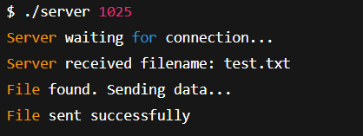
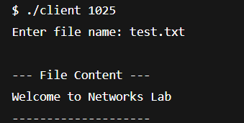

Program 3: Using UDP sockets, write a client-server program to make client sending the file name and the server to send back the contents of the requested file if present.
Code:
Server side: udp_server.c
#include <stdio.h>
#include <stdlib.h>
#include <string.h>
#include <unistd.h>
#include <netinet/in.h>

int main()
{
int sockfd, len;
char filename[256], buffer[2000], filedata[20000];
struct sockaddr_in serv, cli;
FILE *fp;

sockfd = socket(AF_INET, SOCK_DGRAM, 0);

serv.sin_family = AF_INET;
serv.sin_port = htons(7777); // Fixed port
serv.sin_addr.s_addr = INADDR_ANY;

bind(sockfd, (struct sockaddr *)&serv, sizeof(serv));

len = sizeof(cli);
printf("UDP Server waiting...\n");

bzero(filename, 256);

recvfrom(sockfd, filename, sizeof(filename), 0,
(struct sockaddr *)&cli, &len);

printf("Server received filename: %s\n", filename);

fp = fopen(filename, "r");

if (fp == NULL)
{
strcpy(buffer, "File not found");
sendto(sockfd, buffer, strlen(buffer), 0,
(struct sockaddr *)&cli, len);
printf("File not found\n");
}
else
{
bzero(filedata, 20000);
while (fgets(buffer, 2000, fp) != NULL)
{
strcat(filedata, buffer);
}

sendto(sockfd, filedata, strlen(filedata), 0,
(struct sockaddr *)&cli, len);

printf("File sent successfully\n");
fclose(fp);
}

close(sockfd);
return 0;
}
CLIENT CODE (udp_client.c)
#include <stdio.h>
#include <stdlib.h>
#include <string.h>
#include <unistd.h>
#include <netinet/in.h>

int main()
{
int sockfd, len;
char filename[256], buffer[20000];
struct sockaddr_in serv;

sockfd = socket(AF_INET, SOCK_DGRAM, 0);

serv.sin_family = AF_INET;
serv.sin_port = htons(7777);
serv.sin_addr.s_addr = INADDR_ANY;

printf("Enter file name: ");
scanf("%s", filename);

sendto(sockfd, filename, strlen(filename), 0,
(struct sockaddr *)&serv, sizeof(serv));

len = sizeof(serv);

bzero(buffer, 20000);

recvfrom(sockfd, buffer, sizeof(buffer), 0,
(struct sockaddr *)&serv, &len);

printf("\n--- File Content ---\n");
printf("%s\n", buffer);
printf("--------------------\n");

close(sockfd);
return 0;
}
Output:
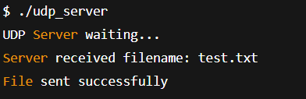
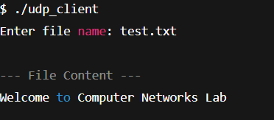

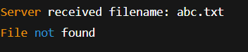
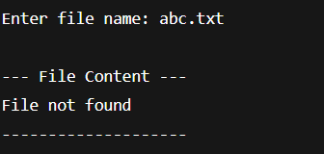

Program 4: Write a program for error detecting code using CRC-CCITT (16-bits).
Code:
#include <stdio.h>
#include <string.h>
#include <stdlib.h>

int main() {
char rem[50], a[80], s[80], c, msj[50], gen[30];
int i, genlen, t, j, flag = 0, k, n;

printf("Enter the generator polynomial (example: 10001000000100001 for CRC-CCITT):\n");
gets(gen);

printf("Generator polynomial is CRC-CCITT: %s\n", gen);

genlen = strlen(gen);
k = genlen - 1;

printf("Enter the message:\n");
n = 0;
while ((c = getchar()) != '\n' && c != EOF) {
msj[n++] = c;
}
msj[n] = '\0';

// Copy message and append k zeros
for (i = 0; i < n; i++)
a[i] = msj[i];
for (i = 0; i < k; i++)
a[n + i] = '0';
a[n + k] = '\0';

printf("\nMessage polynomial appended with zeros:\n");
puts(a);

// Division to get remainder
for (i = 0; i < n; i++) {
if (a[i] == '1') {
t = i;
for (j = 0; j <= k; j++) {
a[t] = (a[t] == gen[j]) ? '0' : '1';
t++;
}
}
}

// Extract remainder
for (i = 0; i < k; i++)
rem[i] = a[n + i];
rem[k] = '\0';

printf("The checksum (remainder) is:\n");
puts(rem);

printf("\nMessage with checksum appended:\n");
for (i = 0; i < n; i++)
a[i] = msj[i];
for (i = 0; i < k; i++)
a[n + i] = rem[i];
a[n + k] = '\0';
puts(a);

// Receiver side
printf("\nEnter the received message:\n");
n = 0;
while ((c = getchar()) != '\n' && c != EOF) {
s[n++] = c;
}
s[n] = '\0';

// Re-division at receiver
for (i = 0; i < n; i++) {
if (s[i] == '1') {
t = i;
for (j = 0; j <= k; j++, t++) {
s[t] = (s[t] == gen[j]) ? '0' : '1';
}
}
}

// Check remainder at receiver
for (i = 0; i < k; i++)
rem[i] = s[n + i];
rem[k] = '\0';

for (i = 0; i < k; i++) {
if (rem[i] == '1')
flag = 1;
}

if (flag == 0)
printf("Received polynomial is ERROR-FREE\n");
else
printf("Received polynomial contains ERROR\n");

return 0;
}

Output:
